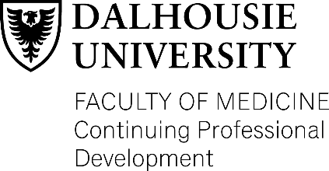
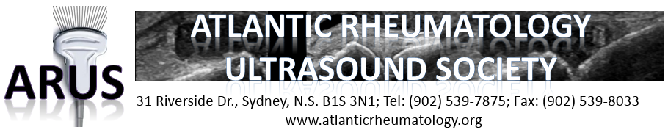
6th Annual Inverness Ultrasound Conference : “Arthros & Algos”

July 15-17, 2023, Inverness Consolidated Hospital, NS, Canada

Saturday, July 15
Ultrasound in daily practice. Instructors: GE, Drs. Mark Bennett & Susie Egar
9.45am – 10.30am Ultrasound as part of clinical exam (FAST scan, etc.)
10.30am – 11.15am Aspects of rheumatology patient assessments with non-rheumatology ultrasound (ILD, pleural effusions, CHF, etc)
MSK US: hand and wrist. Instructors: Drs. Faith Dodd & Juris Lazovskis
11.15am– 12.00pm Clinical and ultrasonographic correlates of hand and wrist pathology: inflammatory v. orthopedic
12.00pm – 1.30pm Lunch break at The Annex
MSK US: elbow and arm. Instructors: Drs. Diane Wilson & Faith Dodd
1.30pm – 2.15pm Anatomy of elbow and arm in view of causes of pain (Dr. Wilson)
2.15pm – 3.00pm Practical approaches to diagnosis and management of tendonitis, epicondylitis, entrapment syndromes (Dr. Dodd)
3.00pm – 3.45pm Ultrasound guided nerve identification and blocks in arm (Dr. Wilson)
Sunday, July 16
MSK US: shoulder. Instructors: Drs. Alessandra Bruns & Zach Shaffelburg
9.45am – 10.30am Basics of shoulder MSK exam: what to expect in normality (Drs. Shaffelburg, Bruns)
10.30am – 11.15am Can ultrasound help to diagnose PMR and how to differentiate from late onset RA and CPPD disease? (Dr. Shaffelburg)
11.15am – 12.00pm Basic approach to diagnosing rotator cuff pathology: clinical and US findings (Dr. Bruns)
12.00pm – 1.30pm Lunch break at The Annex
MSK US: shoulder. Instructors: Drs. Alessandra Bruns & Diane Wilson
1.30pm – 2.15pm Shoulder pain – review of cases (Dr. Bruns)
2.15pm – 3.00pm Shoulder pain management – Analgesia perspective: suprascapular block, intraarticular, intrabursal injections (Dr. Wilson)
3.00pm – 3.15pm Shoulder pain – review of cases (Dr. Bruns)
Monday, July 17
MSK lower extremity injections and cases. Instructors: Drs. Juris Lazovskis & Diane Wilson
9:00am – 9:45am Ultrasound guided nerve identification and blocks in leg (Dr. Wilson)
9:45am – 10.30am Case based demonstrations of most common pathologies: arthritis, tenosynovitis, bursitis, SI joints, facet joints etc. (Drs. Wilson and Lazovskis)
10.30am Conclusion

